 | 7.2.19 Editors - 3D Viewport - Tool Shelf - Lattice - Edit Mode

Table of content
Tool Shelf - Lattice - Edit Mode 1
Select, 3D Cursor, Transform, Measure and Annotate tools 1
Shear 1
Tool Settings 1
Orientation 2
Drag 2
Active Tool 2
Tweak, Select Box, Circle and Lasso 2
Last Operator Shear 2
Offset 2
Axis 2
Axis Ortho 2
Orientation 2
Mirror Editing 2
Proportional editing 2
Proportional Falloff 2
Proportional Size 2
Connected 3
Projected(2D) 3

Tool Shelf - Lattice - Edit Mode
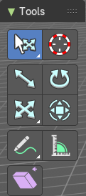

Select, 3D Cursor, Transform, Measure and Annotate tools
The Select, 3D Cursor, Transform, Measure and Annotate tools at the end of the list are explained in the chapter 7.1.1 Editors - 3D View - Tool Shelf - Object Mode. We won't cover this tools again here.

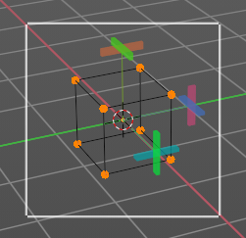
Shear
Shear shears the selection. When you activate the tool then you will reveal a widget. This widget allows you to shear the selection in all possible axis.

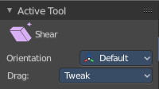
Tool Settings

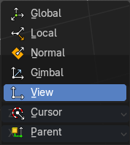
Orientation
Choose the orientation for the shear action.

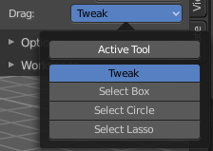
Drag
When you click at the widget of the active tool, then you perform the tool action. Adjust what should happen when you click outside of the widget, in the empty area.

Active Tool
When you click off the widget then the click still does the same than clicking at the widget. It performs the active tool.

Tweak, Select Box, Circle and Lasso
When you choose this options then you will set the off click to the different select methods. Whereas tweak works more than a move tool then. Tweak is the default.

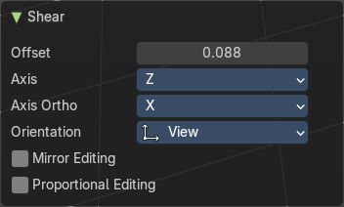
Last Operator Shear

Offset
Adjust an offset.

Axis
Defines one axis of the imaginary shear axis plane.

Axis Ortho
Defines the other axis of the imaginary shear axis plane.

Orientation
Choose the orientation for the shear action.

Mirror Editing
Enable Mirror Editing

Proportional editing
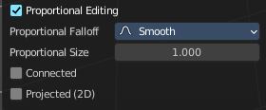
Enables proportional editing. Activating proportional editing reveals further settings.

Proportional Falloff
Adjust the falloff methods.

Proportional Size
See and adjust the falloff radius.

Connected
The proportional falloff gets calculated for connected parts only.

Projected(2D)
The proportional falloff gets calculated in the screen space. Depth doesn't play a role. When it's in the radius, then it gets calculated.

